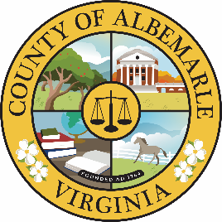

Proclamation Celebrating Martin Luther King, Jr. Day

WHEREAS, Just a century after the Emancipation Proclamation, in 1963, Dr. King and allied forces marched on Washington and delivered the revered “I have a Dream” speech, advocating for the end of racial segregation and societal inequality; and,

WHEREAS, Dr. Martin Luther King, Jr. and other civil rights leaders devoted their lives to the expansion of civil rights and ​public service to all Americans; and

WHEREAS, In honoring his legacy, MLK Day is the only federal holiday designated as a National Day of Service to encourage all Americans to volunteer to improve their communities; and,

WHEREAS, Albemarle County has invested in creating a more equitable and inclusive society by centering Community as an organizational value which states that “we expect diversity, equity, and inclusion to be integrated into how we live our mission” to serve all members of our community; and,

NOW, THEREFORE, BE IT PROCLAIMED, that we, the Albemarle County Board of Supervisors, do hereby honor and celebrate January 20, 2025, as Martin Luther King, Jr. Day and encourage our employees and residents to work towards his vision for a more equitable and inclusive society.

Signed this 15th day of January 2025

_______________________________________
Jim H. Andrews, Chair
Albemarle Board of County Supervisors

